Week 1-4

SNHU CS-230

D. Loranger

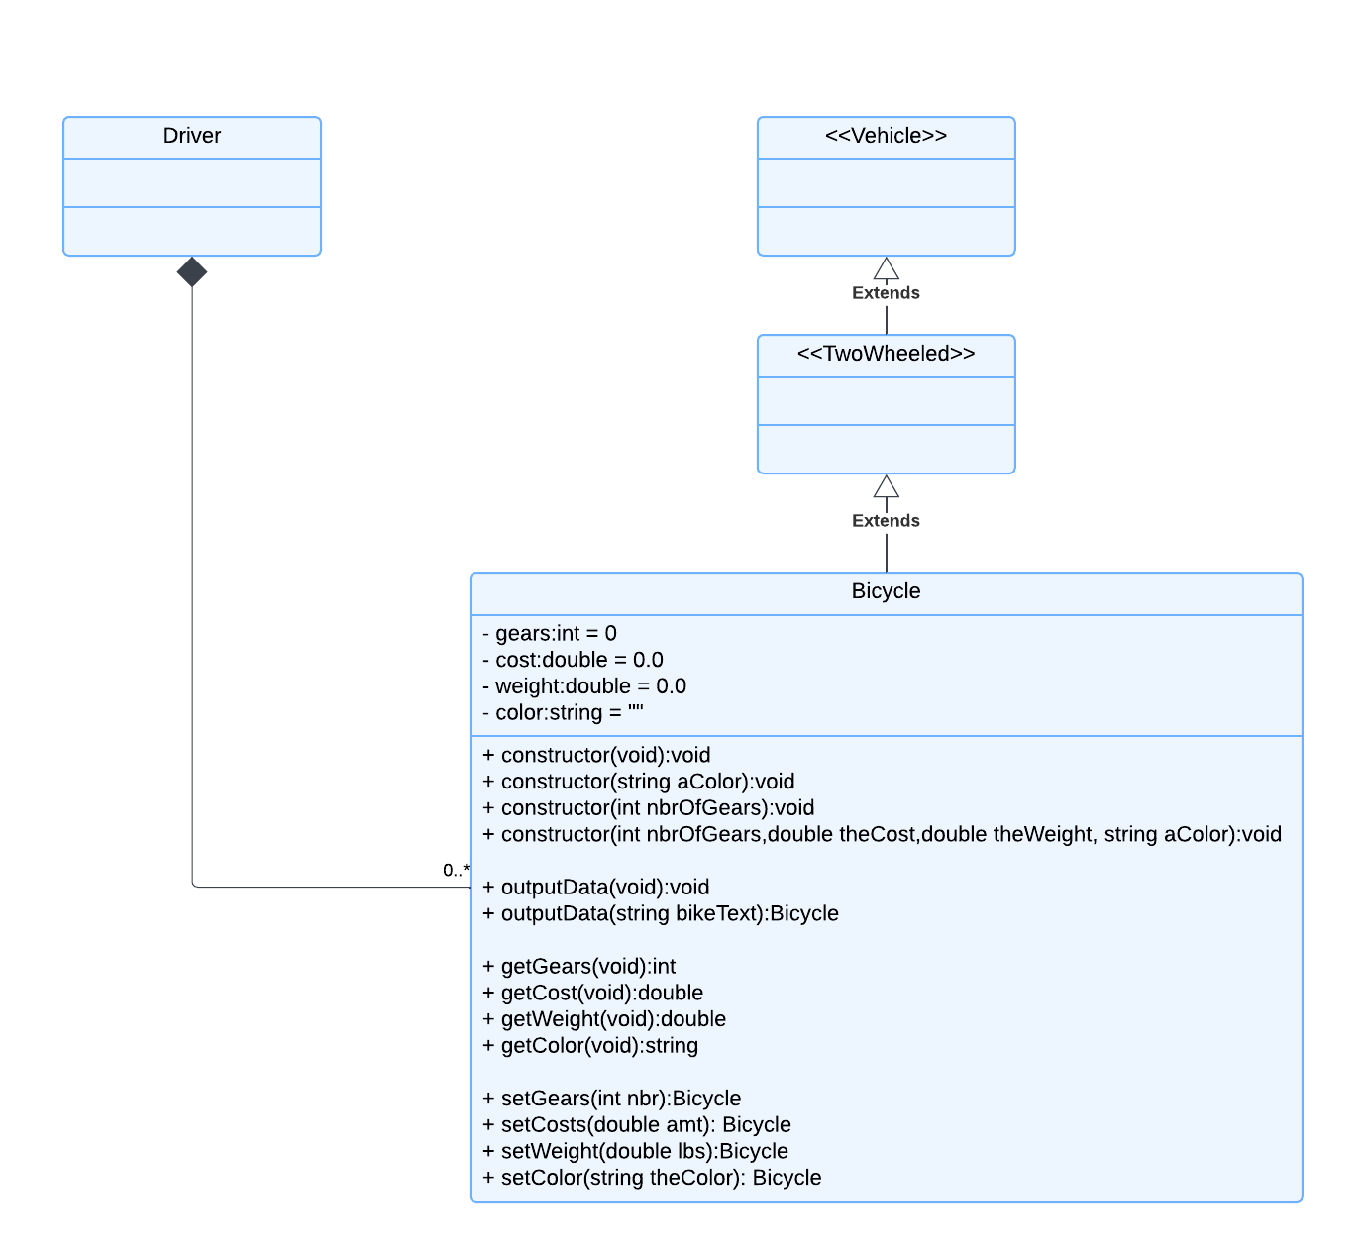

As provided, the *Bicycle* class extends ((inheritance) hallow arrow which points to a prototype with chevrons around the class name) *TwoWheeled* class which also extends ((inheritance) (hallow arrow which points to a prototype with chevrons around the class name) the *Vehicle* class. The *Vehicle* and *TwoWheeled* classes currently are empty, but properties added to these classes would be extended to the *Bicycle* class automatically when implemented. Within the existing *Bicycle* class, there exists 4 private variables to describe the object, and there are 4 gets functions to retrieve and 4 set functions to protect the implementation of these private variables.

The bicycle object only exists if the driver exists as the *Driver* class creates the instance of each bicycle object (multiple created), thus needs to cease to exist if the driver instance ceases to exist. This is represented by the black diamond. A driver object can (and does) have multiple bicycle objects, so the multiplicity is from 0 to many.

The *Bicycle* class constructor has multiple overload options (polymorphism), allowing the instantiating object (driver) multiple options for how to create and initialize the object (bicycle).